**FACEBOOK LOGIN API MODULE**

*High level design including a component diagram:-*

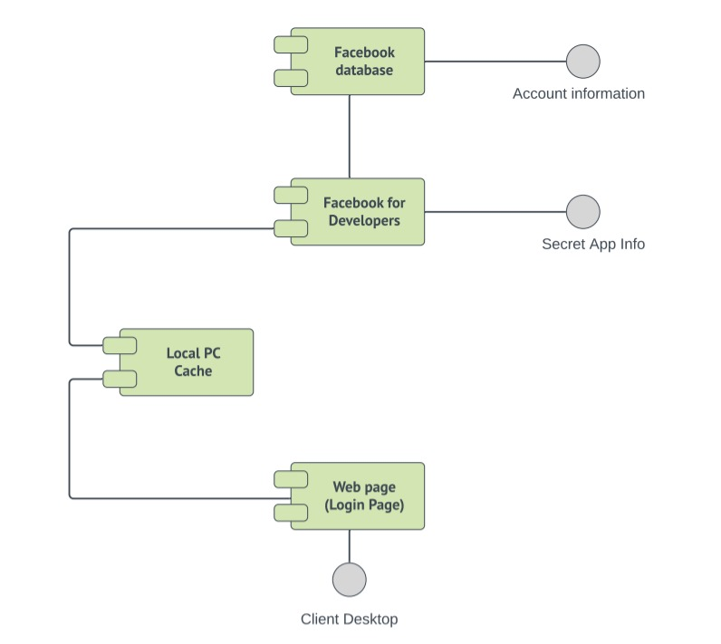

*Low level design including a detailed design diagram :-*

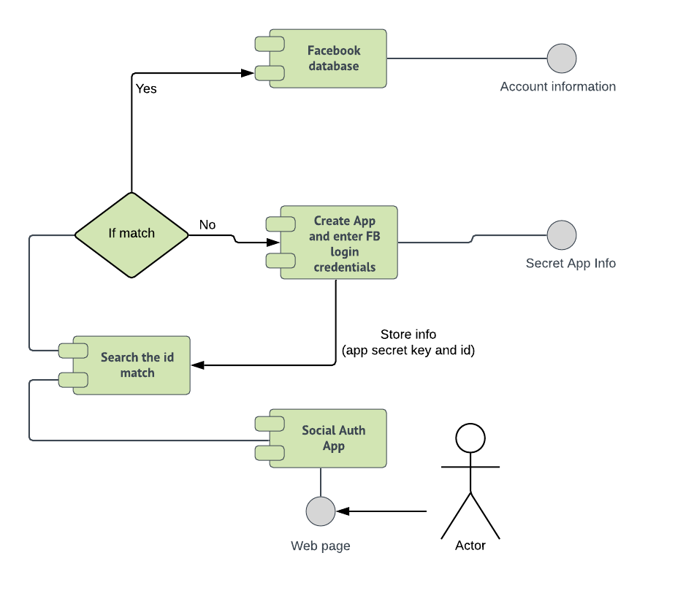

**Web Page**: Clients on accessing the web page have an option to login using an existing account or through gmail or facebook, or sign up. Here the user can choose the Facebook option.

**Social Auth App**: This is the Django component of the python-social-auth ecosystem, it implements the needed functionality to integrate social auth-core in a Django based project.

**Search the id match**: It is the local PC cache where the app secret key and id generated using the facebook api webtools at developers website are stored.

If the user has already login before using Facebook, then if the user tries to login again (within a given time period) then there will be a credential and secret key match in the cache itself and information from the user's account will be directly accessed using the Facebook Database.

Otherwise, first the app secret key will be generated and stored in the cache and then it will connect to the Facebook Database for the account information.

**Creating App for login**: [This](https://developers.facebook.com/) is the facebook developer website. Here using the login credentials the app id and secret key are generated by the third party app which one will have to create for their security purpose.

Then this key is used to authenticate the credentials through the Facebook Login API plugin.

**Facebook Database**: All various kinds of information associated with a facebook ID and more are stored here. Facebook uses many different types and combinations of databases. The required information is retrieved from the database and the information extraction part is automated, we(developer) just have to set the required information, permissions, etc.